Browser Game

What this game is?  
The game where you try to solve a simple puzzle but you will be distracted by many kinds of distraction (in the form of pop-up video and audio) where the player needs to close it pop-up to play it properly. I want this game to simulate my ADHD experience where I am always distracted by many things that are interesting, making me always ignore my main task.

Specification

Browser game that can be played at any device (PC & Mobile/Android/Ios)

Gameplay element

Slide puzzle or memory game with time limit 3-5 min (game that easy to play but need focus)

Clicking pop-up (in form of picture and video ) to distract players and clicking the pop-up instead.

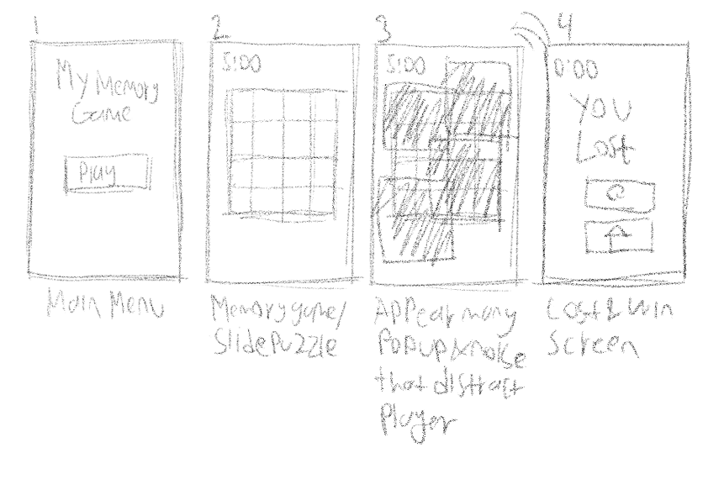

1. Main Menu (Title: “My Memory Game”)  
   Just showing title & play button
2. First 15 second of the game (Game time limit 3-5, make time is shorter or game took longer)  
   Game played just like normal game
3. Rest of the game 15 sec - 15 sec before game end

Player will distracted with many thing of pop-up and audio and the pop-up covering the game and every time player closing the pop-up another pop-up will appear, make player clearing the pop-up instead play the game

If possible player can't finish the game to evoke emotions

1. Lost & Win screen  
   Showing “You WIn” or “You Lost” & restart/back to main menu button

Sample of distraction  
Picture  
In form of meme

Example:

<https://knowyourmeme.com/memes/kazuya-guy>  
<https://knowyourmeme.com/memes/gigachad>

Video

Meme video

Music video  
Learning/how to video (3D, drawing, cooking etc)

example:   
<https://www.youtube.com/watch?v=nIoXOplUvAw&t=95s>  
<https://www.youtube.com/watch?v=iChssoYXsuA&t=93s>  
<https://www.youtube.com/watch?v=UnIhRpIT7nc&t=50s>  
<https://www.youtube.com/watch?v=YS0h2-hy9rw&t=48s>  
<https://www.youtube.com/watch?v=HCq1OcAEAm0>

Audio

Any type of notification (ex: phone like samsung or ios notification tune)

Clock noise and knocking noise (sound that can make anxiety)